James Lawlor, DO, MBA, FACOI  Architect of Semi-Concierge Medicine® • Founder, AMMP & Tributary Advisory Group | 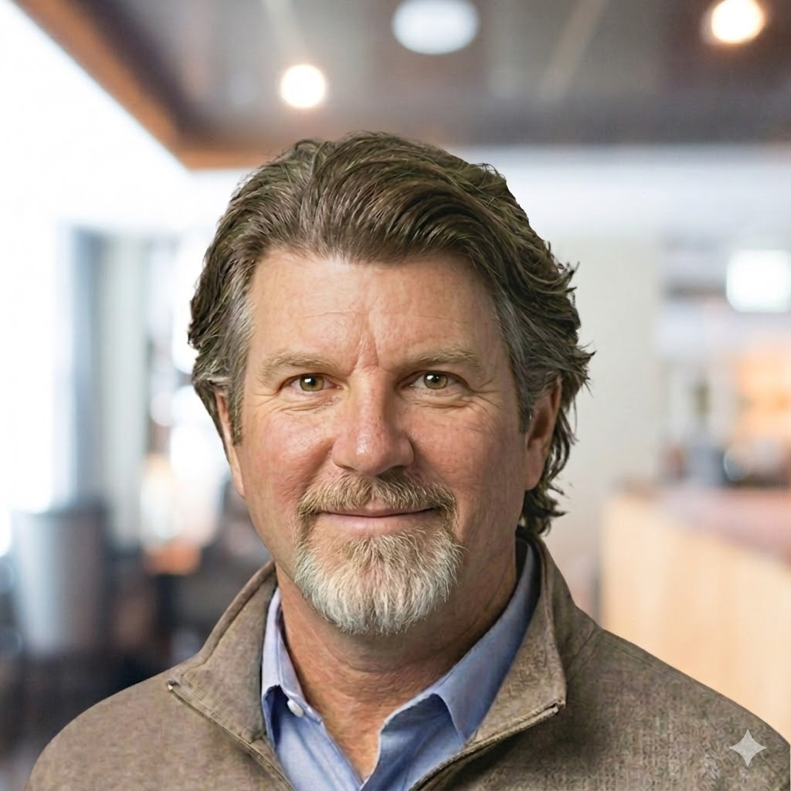

Board-Certified Internist | MBA • OSU Fisher College | FACOI | Asst. Clinical Professor, OSU COM

ABOUT JIM

Dr. James Lawlor is a board-certified internist, health system innovator, and the creator of the Semi-Concierge Medicine® (SCM) model—a membership-based primary care framework designed to bridge the gap between high-volume fee-for-service care and traditional concierge medicine. As Medical Director of the Executive Health Program at The Ohio State University Wexner Medical Center, he led the program's complete financial and operational turnaround, implementing what is widely recognized as the first SCM program within a major academic health system.
Jim holds an MBA from the OSU Fisher College of Business and a graduate minor in public policy from the John Glenn School of Public Affairs. He is the founder of Tributary Advisory Group (TAG), which advises health systems, physician groups, and innovators on membership medicine strategy and implementation. He also serves as founder and board chair of the Association of Membership Medicine Professionals (AMMP)—a 501(c)(6) organization uniting clinicians, health systems, and allied professionals across the full membership medicine spectrum.
In 2025, Jim was named a Top Physician Leader in Concierge Medicine by Concierge Medicine Today.

TALK TOPICS

01 | Middle Ground Membership Models (such as Semi-Concierge Medicine®) & the PRM Curve  How the middle ground between fee-for-service and traditional concierge care works—and why the PRM (Patient Relationship Management) Curve reframes what’s possible in primary care design.

02 | AMMP & the Future of Membership Medicine  The founding of the Association of Membership Medicine Professionals, why a unified professional home matters, and how the field is maturing from a fragmented landscape into a recognized category of care.

03 | Health System Transformation Through Membership Models  A practical framework for how academic and not-for-profit health systems can implement membership medicine—covering financial modeling, operational redesign, team-based staffing, and regulatory alignment.

04 | Physician Burnout & Practice Sustainability  How membership medicine structurally restores physician time, autonomy, and professional satisfaction—and why the solution to burnout is a redesigned care model, not another wellness program.

SUGGESTED INTERVIEW QUESTIONS

Middle Ground Membership Models (such as Semi-Concierge Medicine®) & the PRM Curve
1. What is the PRM Curve, and why do you say it describes the “physics” of care design?
2. How does Semi-Concierge Medicine differ from DPC and traditional concierge—and who is it actually for?
3. You built the first SCM program inside an academic health system. What did that turnaround actually look like?
4. What’s the sweet spot for panel size, and how does it change the patient and physician experience?

AMMP & the Future of Membership Medicine
1. Why did membership medicine need its own professional association, and why now?
2. AMMP spans DPC, concierge, hybrid, and institutional models—how do you hold that tent together?
3. What does “membership medicine as a spectrum” mean, and why does the framing matter?
4. Where do you see membership medicine in healthcare delivery five years from now?

Health System Transformation
1. Most health systems are deeply FFS-oriented. What’s the business case for adding a membership model?
2. What are the biggest operational barriers to implementing SCM inside a large system, and how do you clear them?
3. How do you design a membership model that’s compatible with institutional compliance and payer contracts?
4. What does a scalable growth strategy look like for an academic medical center?

Physician Burnout & Practice Sustainability
1. You’ve said burnout is a structural problem, not a personal one. What do you mean?
2. How does reducing panel size actually change the day-to-day experience of practicing medicine?
3. Can membership medicine survive inside large institutions, or does it require independence?
4. What would you tell a physician who’s burned out but skeptical that a different model is possible?

SHORT BIO FOR SHOW NOTES

Dr. James Lawlor is a board-certified internist, creator of the Semi-Concierge Medicine® model, founder of Tributary Advisory Group, and founder & board chair of the Association of Membership Medicine Professionals (AMMP). He serves as Medical Director of the Executive Health Program at The Ohio State University Wexner Medical Center and was named a Top Physician Leader in Concierge Medicine by Concierge Medicine Today in 2025.

CONNECT & BOOK

Advisory Group  tributaryadvisory.com | AMMP  membermed.org | LinkedIn  www.linkedin.com/in/jim-lawlor/ | X / Twitter  x.com/SayDrJ

Email: booking@tributaryadvisory.com | Phone: (614) 602-2144

